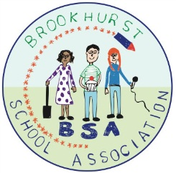 | BSA expenses claim form  Expenses can only be repaid with receipts. Please attach them to this form.
Name:

Amount Claimed:

Cheque/Online transfer (Please circle)
For a cheque please ensure the name above matches the account
For online transfer, please complete the details below.
Sort Code:
Account Number:
Bank:

Event | Item | Amount

Signed:
Date:
We will hold onto this data as part of our accounts for 7 years.

